**LED Flat Downlight Specification**

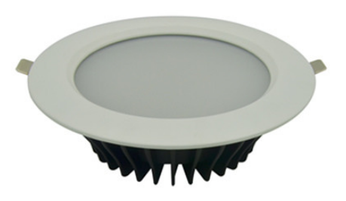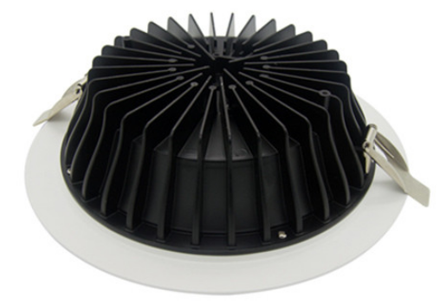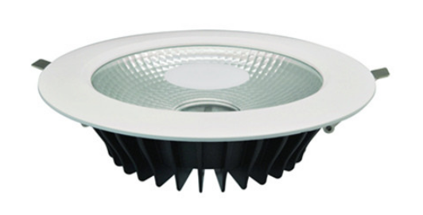

|  |  |  |  |
| --- | --- | --- | --- |
| **Model** | TD056-4F | TD056-6F | TD056-8F |
| **LED Light Source** | CREE LED/Citizen LED/SMD5630 | | |
| **Lamp Watt** | 10-12W | 20W | 30W |
| **Lamp Lumen** | 880lm | 1700lm | 2500lm |
| **Input Voltage** | AC100-240V | | |
| **Size** | D148*H63mm | D195*H63mm | D230*H63mm |
| **Cut Hole** | D125mm | D168mm | D195mm |
| **Inner Package** | 15*15*7cm | 20*20*7cm | 23.5*23.5*7cm |
| **CRI** | >80 | | |
| **Beam Angle** | 90°/ 120 ° | | |
| **CCT** | 3000K,4000K,5000K,6000K | | |
| **Material** | Die-cast Aluminum+Al Reflector+Clear Glass Cover/Frosted PC Cover | | |
| **Adjustable** | Not-Adjustable | | |
| **PF** | >0.90(50/60Hz) | | |
| **Outlook** | White+Black Heat Sink | | |
| **Working Temperature** | -20 to 50℃ | | |
| **IP Rate** | IP44 | | |
| **Warranty** | 3 Years | | |
| **Package** | White Inner Box | | |